### Personal Skills

* Willing to learn
* enthusiastic
* positive thinking
* problem solving
* Responsibility

### Technical Skills

**Operating systems**

* Window,linux

**Programming languages**

* Java,php,c,c++,python

**Databases**

* Mysql,mongoDB

**Ms Office**

* Ms word,Ms powerpoint

**Other Technologies**

* Css,Html,js

### Certificates

* Internet of things by NPTEL

### Languages

* English
* Malayalam

### Hobbies

* Cycling
* Gamming
* Watching series
* Editing

### Academic Details

Master of Computer Application –2021-2023

From KMM college of arts and Science,Thrikkakara

Bachelor of Computer Application –2018-2021

From Siena College Of Professional Studies,Edakochi

Higher Secondary-2016-2018

From St Aloysious Convent ISC School,Palluruthy

High School-2013-2016

From St Aloysious Convent ISC School,Palluruthy

### Academic Projects

* **OnVegS(**Online Vegetable Store to shop vegetables)

Technologies used:front end: Html,css,javascript ,java

back end: MySql

* **Android carpooling app**(android app for carpooling)

Technologies used:front end: Html,css,javascript ,python

back end: MySql

* **Customer churn prediction in bank management** system(predict whether a customer leaves the bank or not)

Technologies used:front end: Html,css,javascript ,python

back end: MySql

algorithm – classification

Steve Rodrigues

+91 6235233153

[steverodrigues369@gmail.com](mailto:steverodrigues369@gmail.com)

kurishu parambil house,nazerth kochi-2

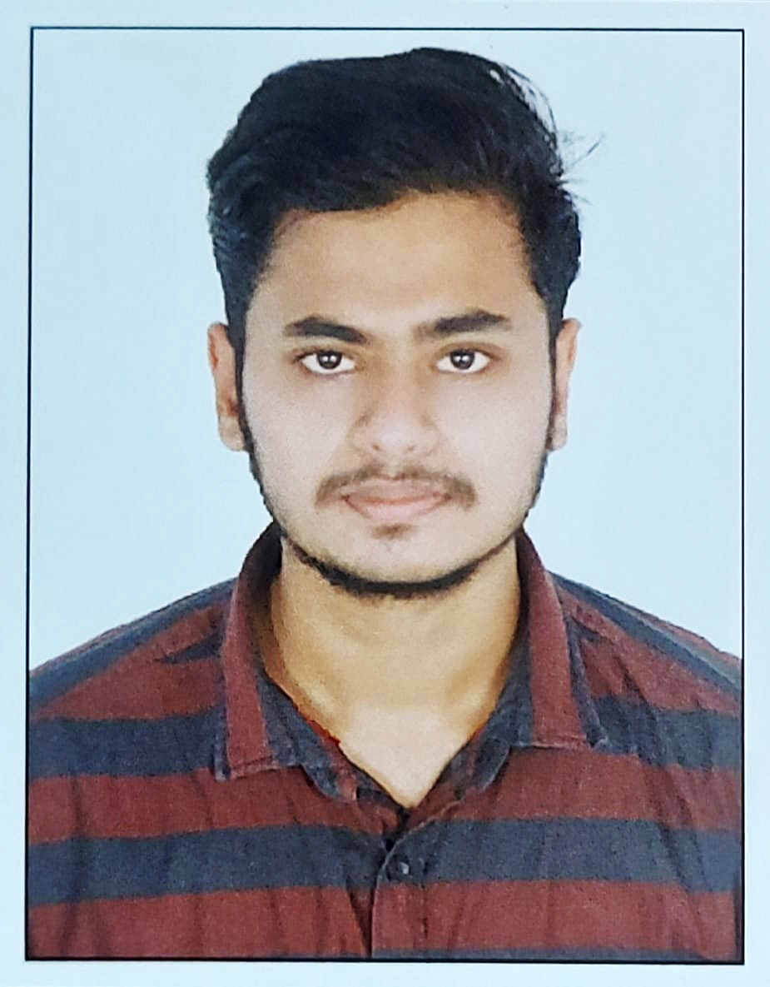

“ To get a challenging and stimulating job in an organization where I can positively contribute my skills and channelize my creativity for the benefit of the organization and acquire new skills in process. ”